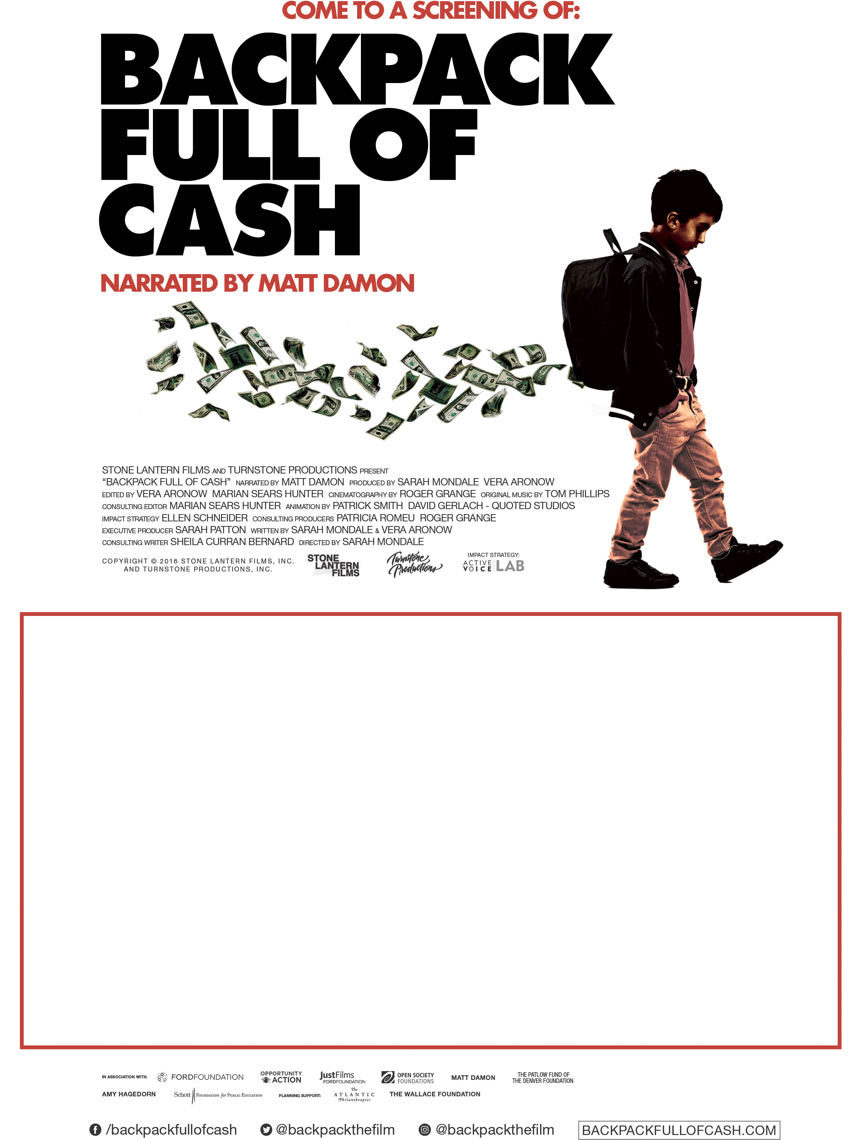

SCREENING TITLE
X:00 PM – Day, Month Date Year

Venue Name
Venue Address
City, State ZIP

Notes about screening.

Sponsor information or other details.

